**URL Shortener Project**

**Project Description :**

We want to build a URL shortener project like Tinyurl. So that we can use this short for sharing and other purposes

**Project Features :**

1. User will **enter the long URL** in the input form
2. User can **see the details** after making the long URL into a short URL in a tabular format
3. User **can copy the short URL link** by clicking the copy button
4. If a user tries to access the short URL **after 2 years, the link will be broken**

Output :

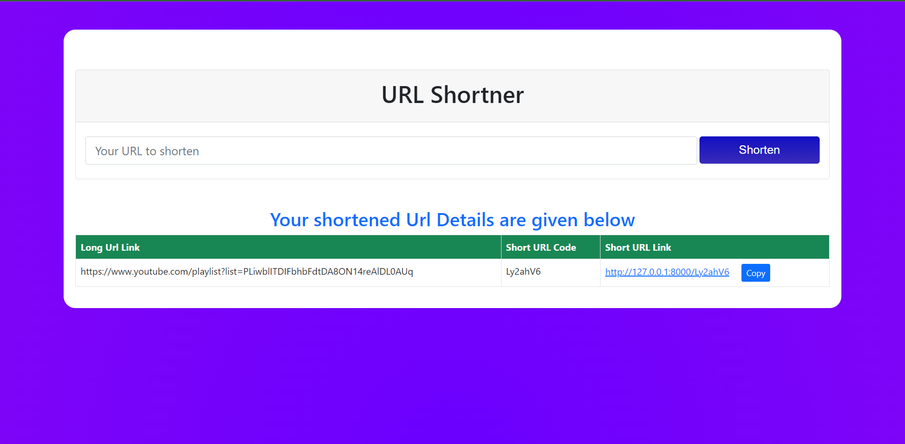

**In the backend :**

1. We are using base62 to make the shortcode for our short URLs
2. In the database, the long URL and short URL links will be saved
3. Whenever a user hits the short URL, it will redirect to the actual URL
4. The short URL will be deleted due to inactivity of almost 2 years
5. We have added a simple javascript code for coping the short link

Our Admin Panel will be looked like this :

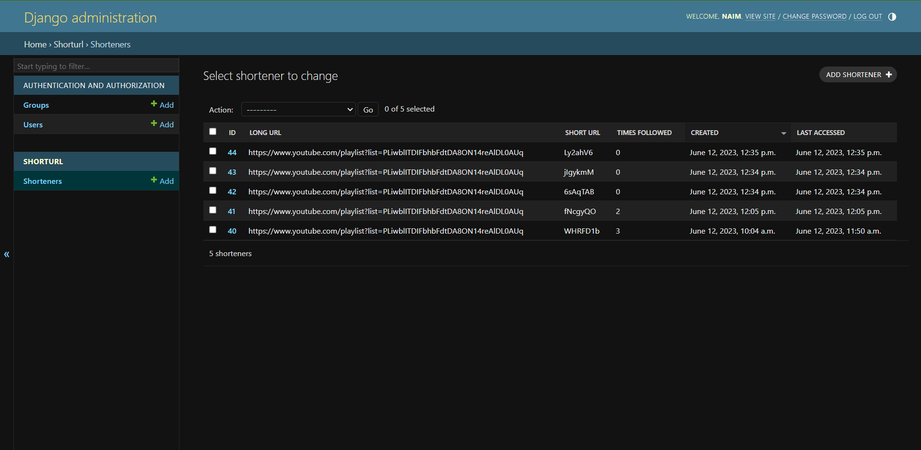

Code link :

<https://github.com/abdullahallnaim/urlshortener>

**You have some fields to extend this project :**

1. You can add the automatic feature when the short links are inactive for almost 2 years then delete the link
2. You can add a custom field so that users can use customize shortcodes for their short links.